PHENIKAA UNIVERSITY
PHENIKAA SCHOOL OF COMPUTING


WEEKLY REPORT
TOPIC: ELECTRONICS E-COMMERCE WEBSITE

Course Class : | Software Architecture-1-2-25 (N01)
Instructor : | M.Sc. Vũ Quang Dũng
Group : | 16
Group Members : | Nguyễn Tuấn Thiền - 23010571  Đặng Việt Anh – 23010689
Mục lục
Lab 04:
1. Overview 2
2. Objectives (Lab 04) 2
3. Practice 1 – Decomposition by Business Capability 2
4. Practice 2 – Service Contracts (API Endpoints) 4
4.1 Catalog (Product) Service Contract 4
4.2 Cart Service Contract 5
4.3 Order & Payment Service Contract (high level) 5
5. Practice 3 – High-Level Communication Strategy 5
5.1. Sequence Diagram – Add to Cart 8
6. C4 Model 8
6.1 C4 Level 1 – System Context 9
6.2 C4 Level 2 – Container 10
6.3 C4 Level 3 – Component (Catalog & Admin Product) 11
6.4 C4 Level 4 – Code (Product Detail Request Flow) 12
7. Mapping Notes to Source Code 12
8. Conclusion 13

1. Overview
This report completes Lab 04 by decomposing the ShopSphere monolithic Laravel application into business-capability microservices, defining service contracts (API endpoints), proposing a high-level communication strategy (synchronous vs asynchronous), and presenting the full C4 Model (Levels 1–4). Although Lab 04 formally requires only C4 Level 1 (System Context), this submission includes all C4 levels to provide a complete architecture view.

2. Objectives (Lab 04)
The objectives for Lab 04 are:
- Understand principles of microservice decomposition (decomposition by business capability).
- Define clear service contracts (API endpoints) for key services.
- Design the system’s high-level communication strategy (synchronous vs asynchronous).
- Model the system using the C4 Model (Level 1: System Context).

3. Practice 1 – Decomposition by Business Capability
The current codebase is a Laravel monolith organized into Modules/ (Admin, Catalog, Cart, Customer, Payment, etc.). The target microservices decomposition preserves these boundaries as candidate services to support service independence and data ownership (no cross-service database access).
Candidate Microservice | Business Capability | Owned Data (Entities / Tables) | Mapping to Web.zip
Customer/Identity Service | Registration, login, profile, wishlist | User, Wishlist | Modules/Customer + app/Models/Models/User.php, Wishlist.php
Catalog (Product) Service | Browse, search, categories, product detail, ratings | Product, Category, ProImage, Rating | Modules/Catalog + app/Models/Models/Product.php, Category.php, ProImage.php, Rating.php
Cart Service | Cart operations and checkout initiation | Cart (cart_items) | Modules/Cart + app/Models/Models/Cart.php
Order Service (proposed split) | Order placement and lifecycle; transactions | Transaction, Order | Currently spread across Cart/Payment; models in app/Models/Models/Transaction.php, Order.php
Payment Service | Payment initiation and callbacks | Payment events / payment records | Modules/Payment + PaymentController routes (MoMo/PayPal/VNPay/QR)
Notification Service | Send confirmation emails and alerts | OutboxMessage + notification logs | app/Models/Models/OutboxMessage.php + notification-service/
Admin Service | Admin UI for catalog, transactions, content | Admin users/actions; product/category mgmt | Modules/Admin (AdminProductController, etc.)
Content Service | Articles/banners/news | Article | Modules/Content + app/Models/Models/Article.php
Support Service | Contact/support requests | Contact | Modules/Support + app/Models/Models/Contact.php
Review Service | Product ratings/reviews moderation | Rating | Modules/Review + app/Models/Models/Rating.php

External dependencies (at least 3) identified for ShopSphere:
- Payment gateways: MoMo, PayPal, VNPay, QR-based payments (integrated in Modules/Payment).
- Email provider (SMTP): used by the Notification Service to send order confirmations.
- Shipping carrier API: recommended for shipment creation and tracking (planned integration).

4. Practice 2 – Service Contracts (API Endpoints)
Service contracts define how services communicate without sharing databases. The following contracts are proposed for the target microservices architecture. A mapping note is included to relate them to the current monolithic routes in Web.zip.

4.1 Catalog (Product) Service Contract
Base URL: /api/products
HTTP Method | Endpoint | Description | Data Returned
GET | /api/products | List/search products (query: q). Returns only active products. | List of product summaries
GET | /api/products/{id} | Retrieve full details for a single product by id. | Product object (name, price, description, images)
GET | /api/products/{id}/price | Lightweight lookup for cart pricing/discount. | { price, sale, currency }
POST | /api/products | Create product (Admin only). | Created product object
Mapping to (current monolith):
- Product list/search: Modules/Catalog/routes/web.php → /san-pham, /danh-muc/{slug}-{id}
- Product detail: Modules/Catalog/routes/web.php → /san-pham/{slug}-{id} handled by ProductDetailController::productDetail()
- Admin product CRUD: Modules/Admin/routes/web.php → /admin/product/* handled by AdminProductController
Microservice boundary requirement: the Cart Service must not access the Catalog database directly; it must use the Catalog service API (e.g., GET /api/products/{id}).

4.2 Cart Service Contract
HTTP Method | Endpoint | Description
GET | /api/cart | Get current cart for the authenticated user.
POST | /api/cart/items | Add item to cart (product_id, quantity).
PUT | /api/cart/items/{itemId} | Update cart item quantity.
DELETE | /api/cart/items/{itemId} | Remove item from cart.
POST | /api/cart/checkout | Start checkout; re-validate price and stock before order creation.
Mapping to: Modules/Cart/routes/web.php (prefix /cart and /oder/pay).

4.3 Order & Payment Service Contract (high level)
Order Service (proposed):
- POST /api/orders – create order (returns 201)
- GET /api/orders/{id} – order details
- GET /api/orders?user_id= – order history
Payment Service (present in Web.zip):
- GET /payment/{method}/{transaction} – payment UI
- POST /payment/{method}/{transaction}/init – initiate payment
- Provider callbacks: /payment/momo/*, /payment/paypal/*, /payment/vnpay/*, /payment/qrcode/*

5. Practice 3 – High-Level Communication Strategy
Synchronous communication is used when the user needs an immediate response (e.g., browsing, cart price lookup, checkout). Asynchronous messaging is preferred for non-blocking tasks (e.g., order confirmation emails) to improve fault isolation.
Interaction | Participants | Type | Rationale
Customer login/profile | Gateway ↔ Customer Service | Synchronous (HTTP) | Immediate response required for auth/profile display.
Product browsing/search | Client ↔ Catalog Service | Synchronous (HTTP) | Interactive browsing requires low latency.
Cart price validation | Cart Service ↔ Catalog Service | Synchronous (HTTP) | Checkout must use accurate price/discount.
Checkout and order creation | Cart Service ↔ Order Service | Synchronous (HTTP) | Order creation must succeed/fail immediately.
Payment processing | Payment Service ↔ Payment Gateway | Synchronous (HTTP callbacks) | Provider-driven return/IPN requires direct callbacks.
Order confirmation email | Order Service → Notification Service | Asynchronous (Redis queue) | Email must not block order completion.

Implementation note (from codebase): ShopSphere already includes an Outbox pattern for reliable async processing. OrderPlaced events are stored in outbox_messages and later published to a Redis queue (notifications), which is consumed by the standalone notification-service to send emails.

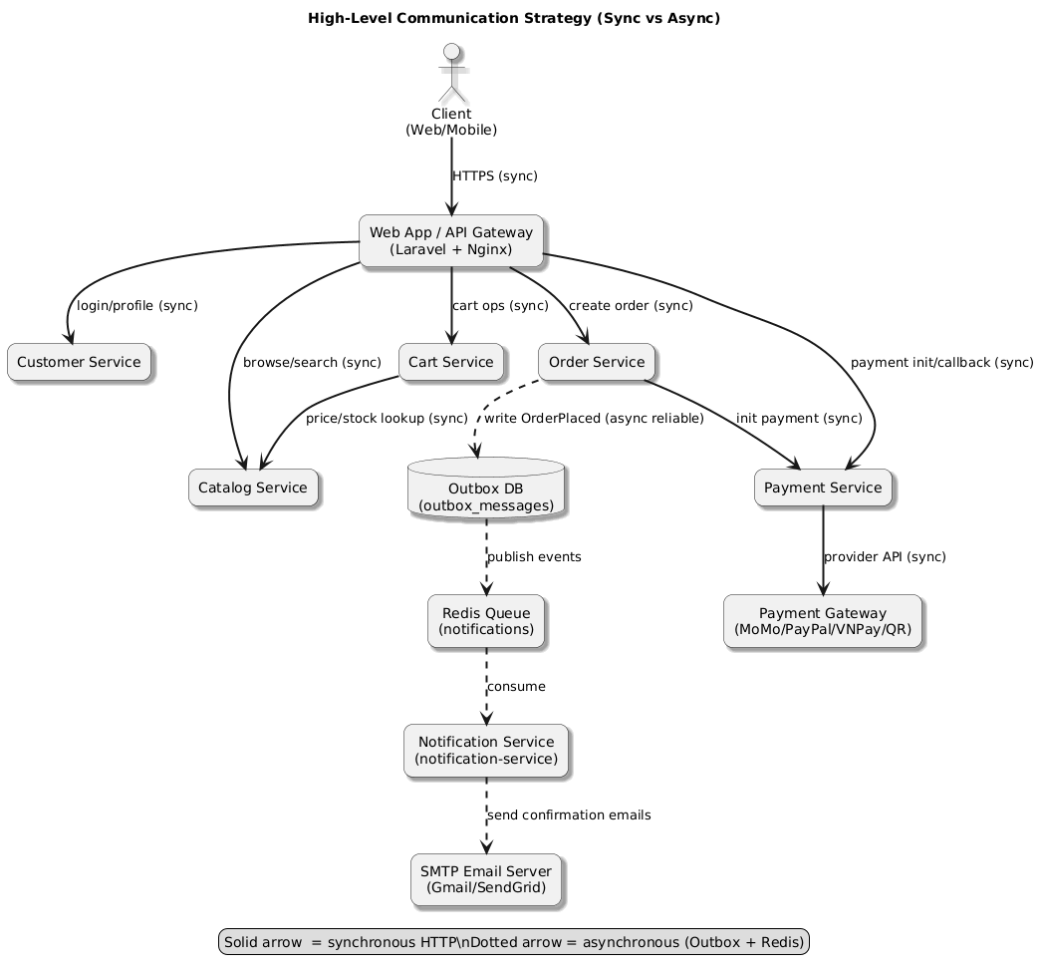
Figure 5.1 High-Level Communication Strategy (sync vs async)

5.1. Sequence Diagram – Add to Cart
This sequence focuses on the synchronous interaction where the Cart Service validates the request and retrieves the product snapshot via the Catalog Service API (no shared database).
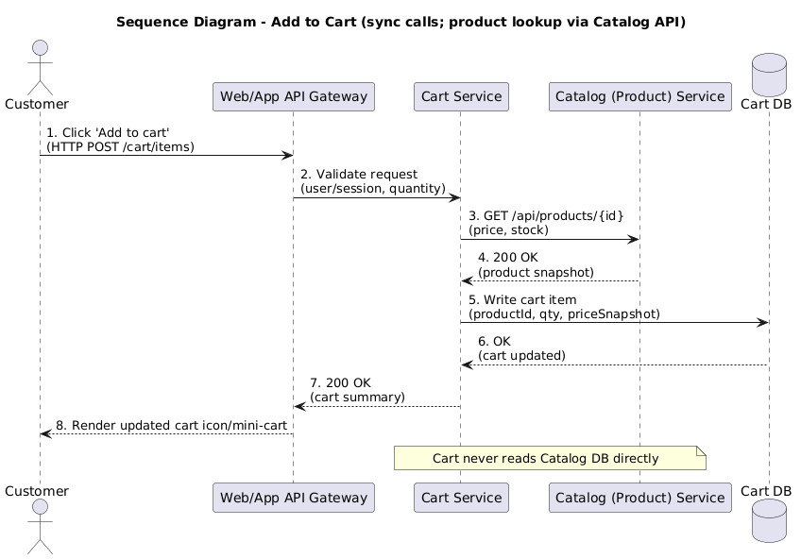
Figure 5.2 Sequence Diagram – Add to Cart (sync calls via REST).

6. C4 Model
Lab 04 requires C4 Level 1 (System Context). Levels 2–4 are included to fully document the architecture and map it to the existing Web.zip structure.

6.1 C4 Level 1 – System Context
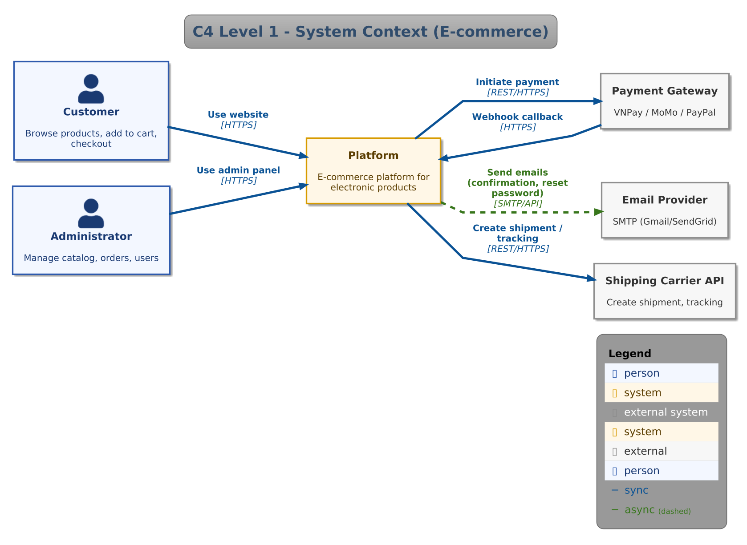
Figure 6.1 C4 Level 1 – System Context

6.2 C4 Level 2 – Container
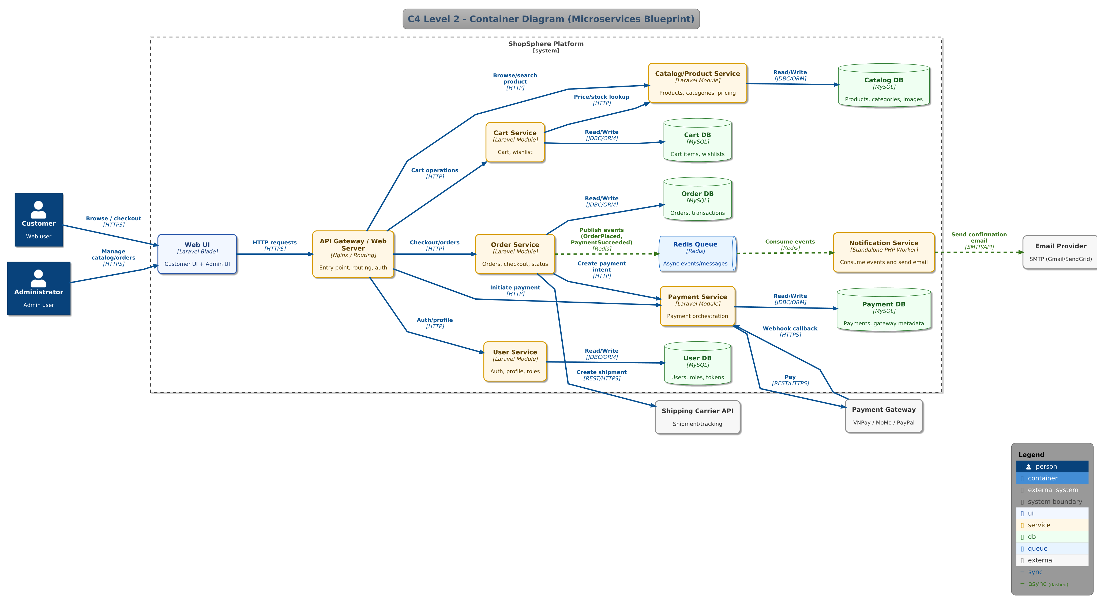
Figure 6.2 C4 Level 2 – Container (Target Microservices)

6.3 C4 Level 3 – Component (Catalog & Admin Product)
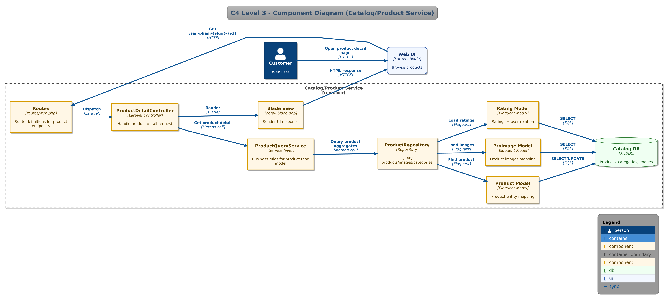
Figure 6.3 C4 Level 3 – Component (Catalog & Admin Product)

6.4 C4 Level 4 – Code (Product Detail Request Flow)
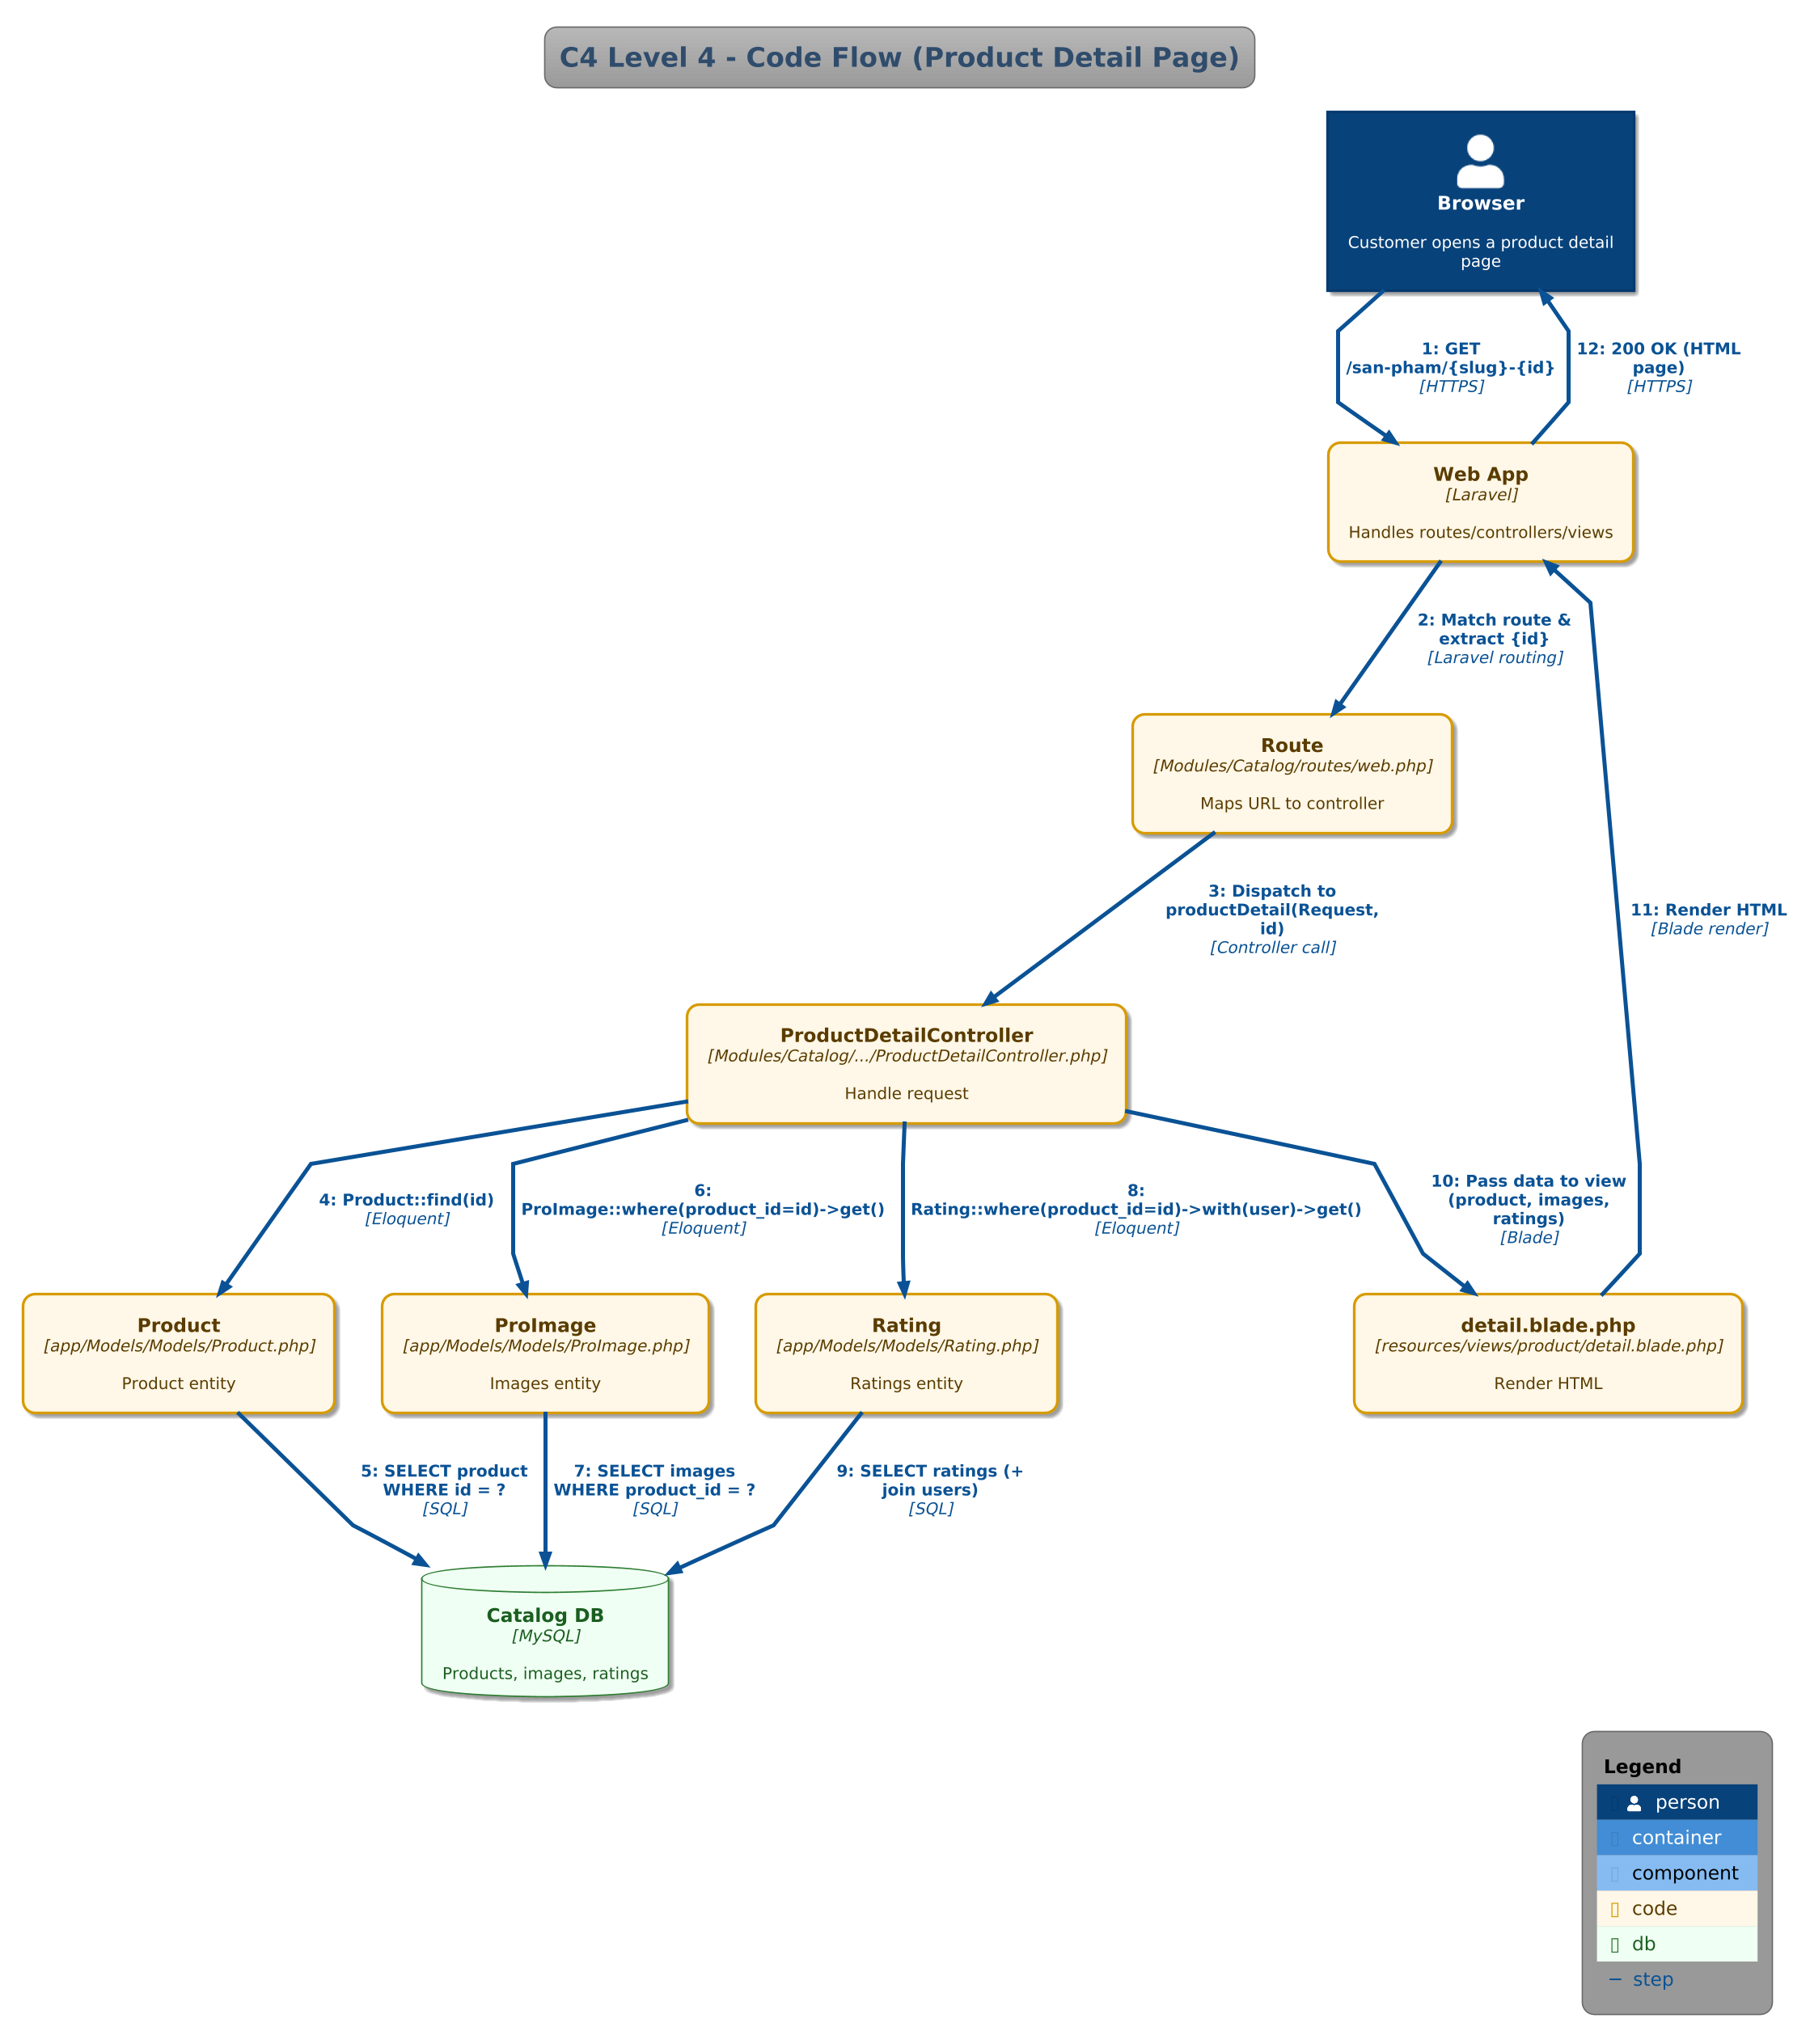
Figure 6.4 C4 Level 4 – Code (Product Detail Request Flow)

7. Mapping Notes to Source Code
Key module boundaries in the codebase:
- Modules/Admin/
- Modules/Cart/
- Modules/Catalog/
- Modules/Content/
- Modules/Customer/
- Modules/Payment/
- Modules/Review/
- Modules/Support/
Key routes supporting the Catalog and Cart capabilities:
- Catalog: Modules/Catalog/routes/web.php (/, /san-pham, /danh-muc/{slug}-{id}, /san-pham/{slug}-{id})
- Cart: Modules/Cart/routes/web.php (/cart/* and /oder/pay)
- Customer/Auth: Modules/Customer/routes/web.php (/auth/*, /user/*, /wishlist/*)
- Payment: Modules/Payment/routes/web.php (payment flows and callbacks)
- Admin product management: Modules/Admin/App/Http/Controllers/AdminProductController.php
Async notification pipeline present in the repository:
- Outbox entity: app/Models/Models/OutboxMessage.php
- Listener: app/Listeners/SaveOrderPlacedToOutbox.php (writes OrderPlaced to outbox_messages)
- Publisher job/command: app/Jobs/PublishOutboxMessages.php and app/Console/Commands/PublishOutboxCommand.php (push to Redis)
- Consumer microservice: notification-service/consumer.php (consumes Redis queue and sends emails via SMTP)

8. Conclusion
This report provides a business-capability decomposition for ShopSphere, defines clear service contracts, documents a synchronous/asynchronous communication strategy, and presents the full C4 model (Levels 1–4). The proposed microservice boundaries align with the existing Laravel Modules/ structure in Web.zip and leverage the existing outbox + Redis-based notification microservice for reliable asynchronous communication.
References
Lab 4: Microservices Decomposition & Communication (Lab handout).
Lecture 4: Microservices Decomposition & Context (Slide deck).

